CAMPAIGN RESEARCH
C0022 -Operation Dream Job
Intern ID: 2169 | Software Range: S0690–S0699

Campaign Overview
Operation Dream Job is a sophisticated, long-running cyber espionage campaign conducted by Lazarus Group, a North Korean state-sponsored APT. The campaign uses fake job recruitment lures posing as recruiters from top defence, aerospace, and technology companies like Boeing, Lockheed Martin, and BAE Systems to trick targets into opening malicious documents and executing malware. It is one of the most creative and well-documented social engineering campaigns in cyber threat intelligence history.
- ATT&CK ID: C0022
- Also Known As: Operation North Star, Operation Interception, DeathNote Campaign
- Status: Long-running (active from at least 2019 to present)
- Classification: Cyber Espionage / Financial Theft

Threat Actor/Group Association
Group | Lazarus Group
Attack ID | G0032
Also Known as | Labyrinth Chollima, Hidden Cobra, Zinc,  Guardians of Peace, Diamond Sleet
Origin | North Korea
Active Since | 2009
Sponsor | State Sponsored Operating under the Reconnaissance General Bureau (RGB)
Motive | Espionage + Finance Gain
Past operations | Wanna cry, Sony pictures hack, Bangladesh bank heist

Timeline
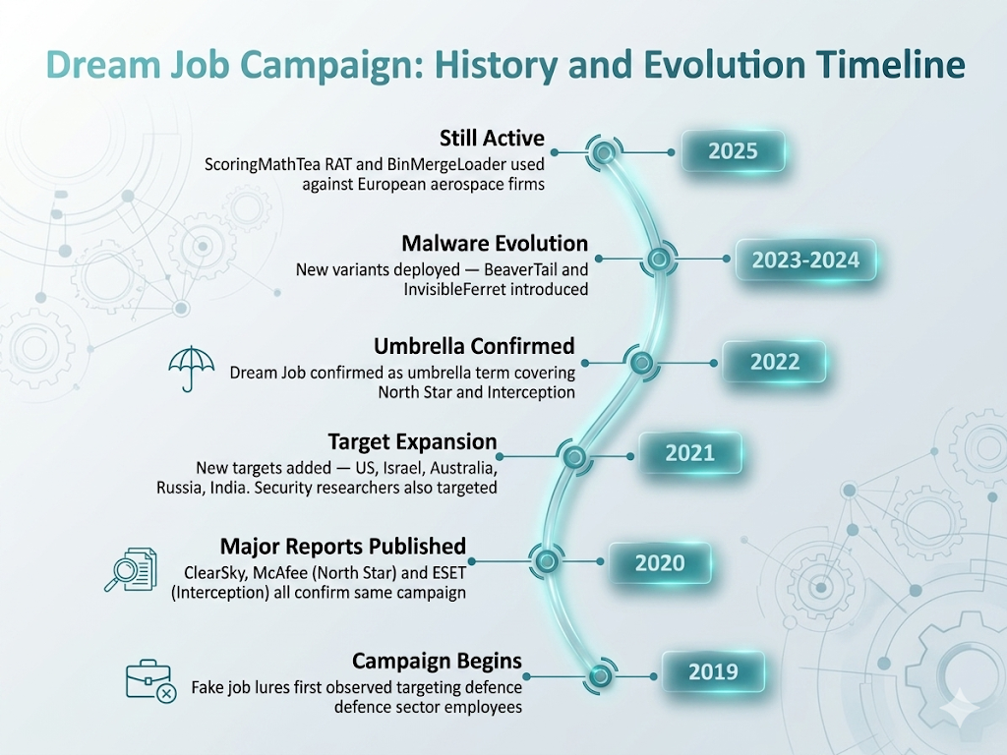

Objectives of Attack
Espionage | -Steal classified defence and aerospace technology secrets
Financial Theft | Monetize network access via Business Email Compromise (BEC)
Credential Harvesting | Collect Login credentials for further access
IP Theft | Steal blueprints, source code, and research data
Persistence | Maintain long-term undetected access in target networks

Targeted Sectors
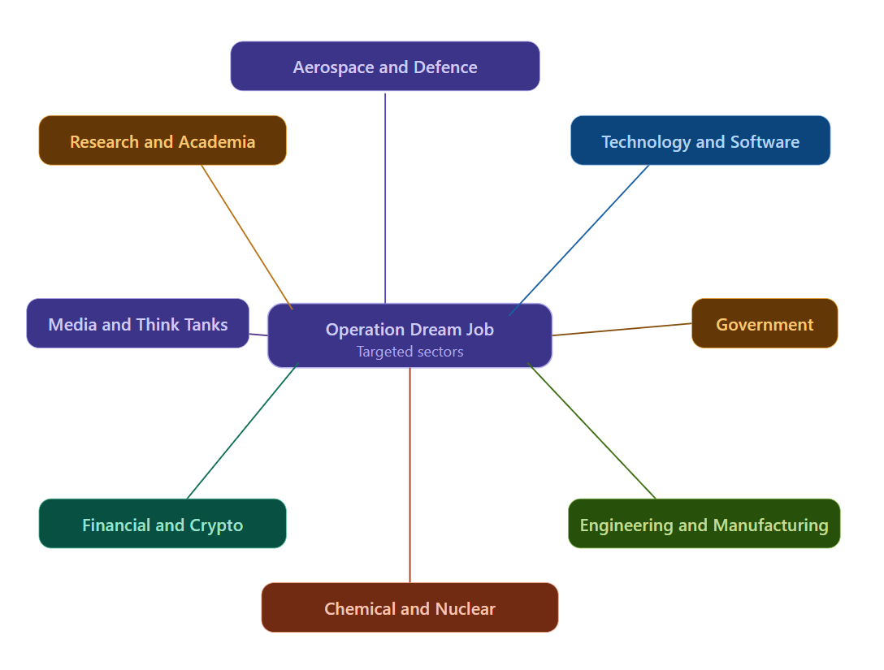
Targeted Regions
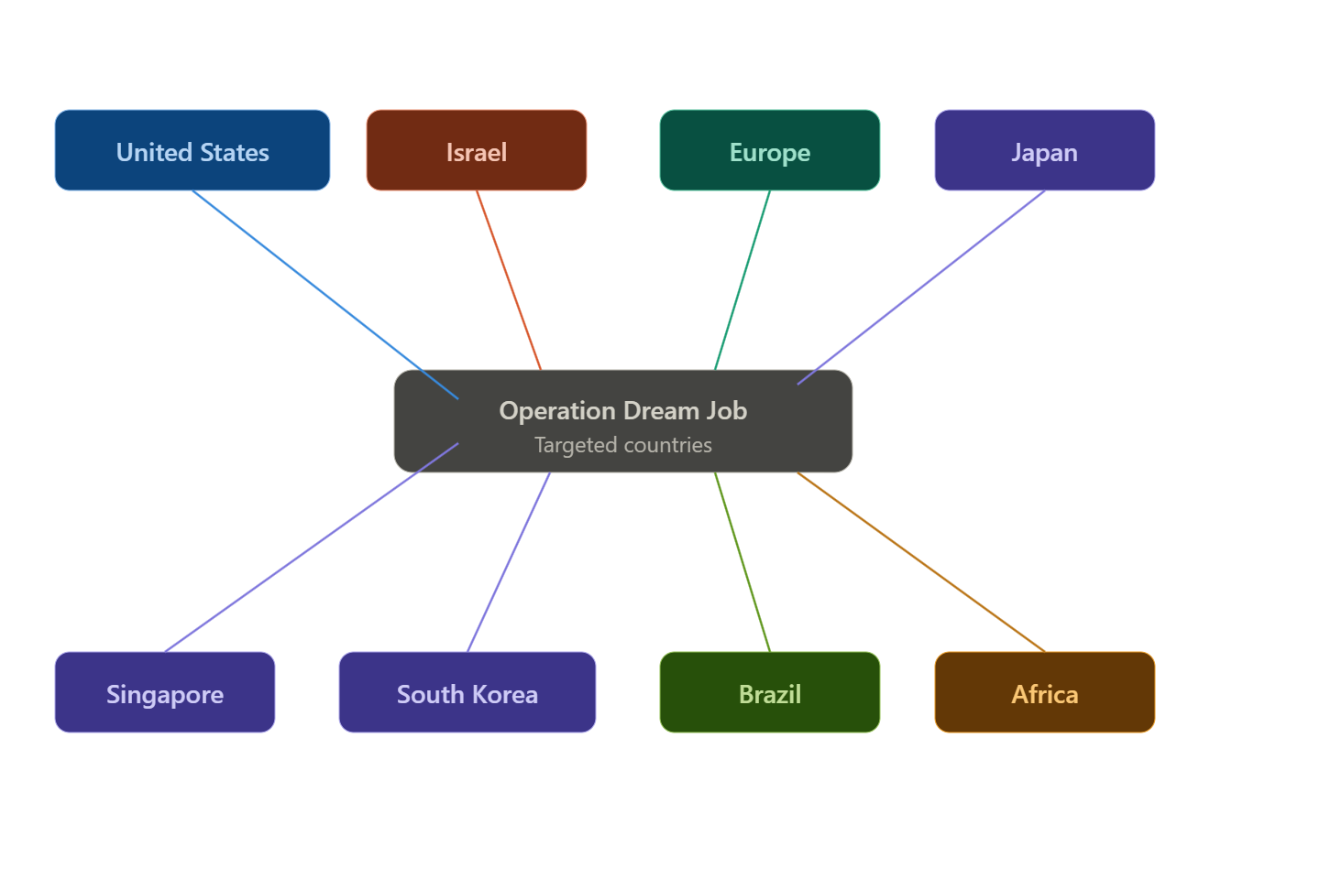

Attack Flow
STEP 1-RESEARCH PHASE
└─ Lazarus identifies high-value defence/aerospace employees
└── Researches targets on LinkedIn, company websites
STEP 2 — INITIAL CONTACT
└── Creates fake recruiter profiles on LinkedIn
└── Sends fake job offers from Boeing, Lockheed Martin ,etc.
└── Technique: T1566.003 — Spear phishing via Service
STEP 3 — DELIVERY
└── Sends malicious Word/PDF documents as "job description"
└── Documents contain malicious macros or exploits
└── Technique: T1566.001 — Spear phishing Attachment
STEP 4 — EXECUTION
└── Victim opens document and enables macros
└── Malware (DRAT zarus /BLINDINGCAN) is dropped and executed
└── Technique: T1204.002 — User Execution: Malicious File
STEP 5 — INSTALLATION
└── RAT installed on victim machine
└── Establishes persistence via Registry Run Keys
STEP 6 — C2 COMMUNICATION
└── Malware beacons to Lazarus C2 server via HTTP/HTTPS
STEP 7 — DISCOVERY & COLLECTION
└── Enumerates system info, users, network topology
└── Collects sensitive files and credentials
STEP 8 — EXFILTRATION
└── Collected data sent back to C2
└── Technique: T1041 — Exfiltration Over C2 Channel

MITRE ATT&CK Techniques Used

Tactic | Technique ID | Technique Name
Reconnaissance | T1591 | Gather Victim Org Information
Reconnaissance | T1593 | Search Open Websites/Domains
Initial Access | T1566.001 | Spearphishing Attachment
Initial Access | T1566.003 | Spearphishing via Service
Execution | T1204.002 | User Execution: Malicious File
Execution | T1059.001 | PowerShell
Execution | T1106 | Native API
Persistence | T1547.001 | Registry Run Keys / Startup Folder
Defense Evasion | T1027 | Obfuscated Files or Information
Defense Evasion | T1036.005 | Masquerading
Defense Evasion | T1497.003 | Time Based Sandbox Evasion
Defense Evasion | T1622 | Debugger Evasion
Credential Access | T1555 | Credentials from Password Stores
Discovery | T1082 | System Information Discovery
Discovery | T1057 | Process Discovery
Discovery | T1018 | Remote System Discovery
Discovery | T1033 | System Owner/User Discovery
Collection | T1005 | Data from Local System
C2 | T1071.001 | Application Layer Protocol: Web Protocols
Exfiltration | T1041 | Exfiltration Over C2 Channel

Real-World Incidents

Incident 1
Defence Contractor Targeting (2020)
- Lazarus posed as Boeing and Lockheed Martin recruiters on LinkedIn
- Sent malicious PDF job offers to defence engineers
- Successfully compromised multiple defence contractor networks
- DRATzarusRAT deployed for persistent access
Incident 2
BEC Monetization Attempt
- In at least one confirmed case, Lazarus attempted to monetize network access
- Used compromised email accounts for Business Email Compromise (BEC)
- Attempted to redirect financial transactions
Incident 3
Operation Interception (2020)
- ESET confirmed aerospace and military companies in Europe and Middle East targeted
- Fake job offers sent via LinkedIn
- Multi-stage infection chain using malicious documents
Incident 4
Contagious Interview (2023–2024)
- Lazarus evolved the campaign to target software developers
- Fake coding interview tasks used to deliver BeaverTail and InvisibleFerret malware
- Targeted cryptocurrency sector specifically

Detection Opportunities

Detection Point | Method
Suspicious Office Macros | Alert on macro execution from downloaded documents
LinkedIn Lure Awareness | Flag unsolicited job offer attachments
RAT C2 Beaconing | Detect regular HTTP beaconing to unknown external IPs
Debugger/Sandbox Checks | Monitor for IsDebuggerPresent and timing API calls
Registry Persistence | Alert on Run Key modifications by Office processes
Process Discovery | Detect rapid system enumeration after document open
UPX Packed Binaries | Flag execution of UPX-packed PE files
Unusual Parent Processes | Word/Excel spawning cmd.exe or PowerShell
Defensive Recommendations
Disable Office Macros by default -only allow signed macros
Security Awareness Training - educate staff about fake LinkedIn job lures
Email Filtering - block malicious attachments and suspicious file types
Endpoint Detection & Response (EDR) - deploy behavioral detection on endpoints
Network Monitoring - alert on unusual outbound HTTP beaconing patterns
Application Whitelisting - prevent execution of unknown/unsigned binaries
Threat Intelligence Feeds - subscribe to Lazarus Group IOC feeds
Privilege Separation - limit user privileges to reduce impact of compromise
Multi-Factor Authentication - protect all external-facing accounts
Incident Response Plan - have a tested IR plan ready for APT-level intrusions

SOFTWARE RESEARCH
S0690 — Green Lambert
Intern ID: 2169 | Campaign: C0022 Operation Dream Job
1. Name & Type
Field | Detail
Name | Green Lambert
ATT&CK ID | S0690
Type | Malware - Modular Backdoor
Also Known As | Part of "The Lamberts" malware family (Blue Lambert, Green Lambert, Red Lambert etc.)
Version | 1.0
Created | March 21, 2022 (MITRE entry)
Last Modified | April 16, 2025

Description
Green Lambert is a highly sophisticated, multi-platform modular backdoor that was first publicly reported by Kaspersky's Global Research and Analysis Team (GReAT) in 2017. However forensic evidence suggests the Windows variant may have been operational as early as 2008, making it one of the longest running implants ever discovered.
A macOS version was uploaded to a malware scanning service in September 2014, confirming its cross-platform development capability.
Green Lambert belongs to a family of related tools collectively called "The Lamberts" or "Longhorn" a highly advanced threat group assessed to be a sophisticated nation-state level actor.
Key Characteristics
- Multi-platform i.e runs on Windows, macOS, Linux and iOS
- Modular architecture - can load additional plugins
- Uses DNS as its primary C2 channel
- Disguises itself as legitimate software
- Self-deletes after installation to remove forensic trace
Threat Actor Association
Field | Detail
Threat Actor | Longhorn / The Lamberts
Also Tracked As | The Lamberts (Kaspersky), Longhorn (Symantec)
Assessment | Nation-state level actor
Suspected Origin | Western nation-state (assessed by multiple researchers)
Activity Period | At least 2008 — 2017+
Targets | Government, military, financial, telecom sectors globally

Supported Platforms
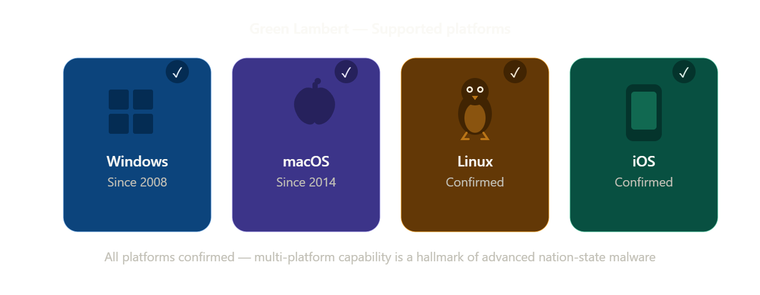

5. ATT&CK Techniques Used
Tactic | ID | Technique Name
Command & Control | T1071.004 | Application Layer Protocol: DNS
Persistence | T1547.015 | Boot or Logon Autostart: Login Items
Persistence | T1037.004 | Boot or Logon Init Scripts: RC Scripts
Execution | T1059.004 | Command and Scripting: Unix Shell
Persistence | T1543.001 | Create or Modify System Process: Launch Agent
Persistence | T1543.004 | Create or Modify System Process: Launch Daemon
Credential Access | T1555.001 | Credentials from Password Stores: Keychain
Collection | T1005 | Data from Local System
Defense Evasion | T1140 | Deobfuscate/Decode Files or Information
Persistence | T1546.004 | Unix Shell Configuration Modification
Defense Evasion | T1070.004 | Indicator Removal: File Deletion
Defense Evasion | T1036.004 | Masquerading: Masquerade Task or Service
Defense Evasion | T1036.005 | Masquerading: Match Legitimate Resource
Defense Evasion | T1027 | Obfuscated Files or Information
Command & Control | T1090 | Proxy
Discovery | T1082 | System Information Discovery
Discovery | T1016 | System Network Configuration Discovery
Discovery | T1124 | System Time Discovery

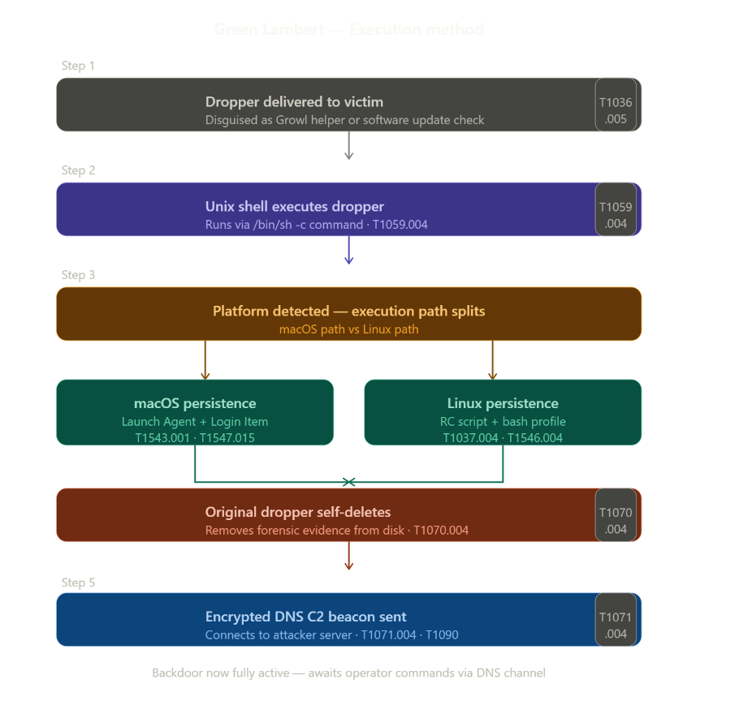
6. Execution Method

7. Persistence Techniques
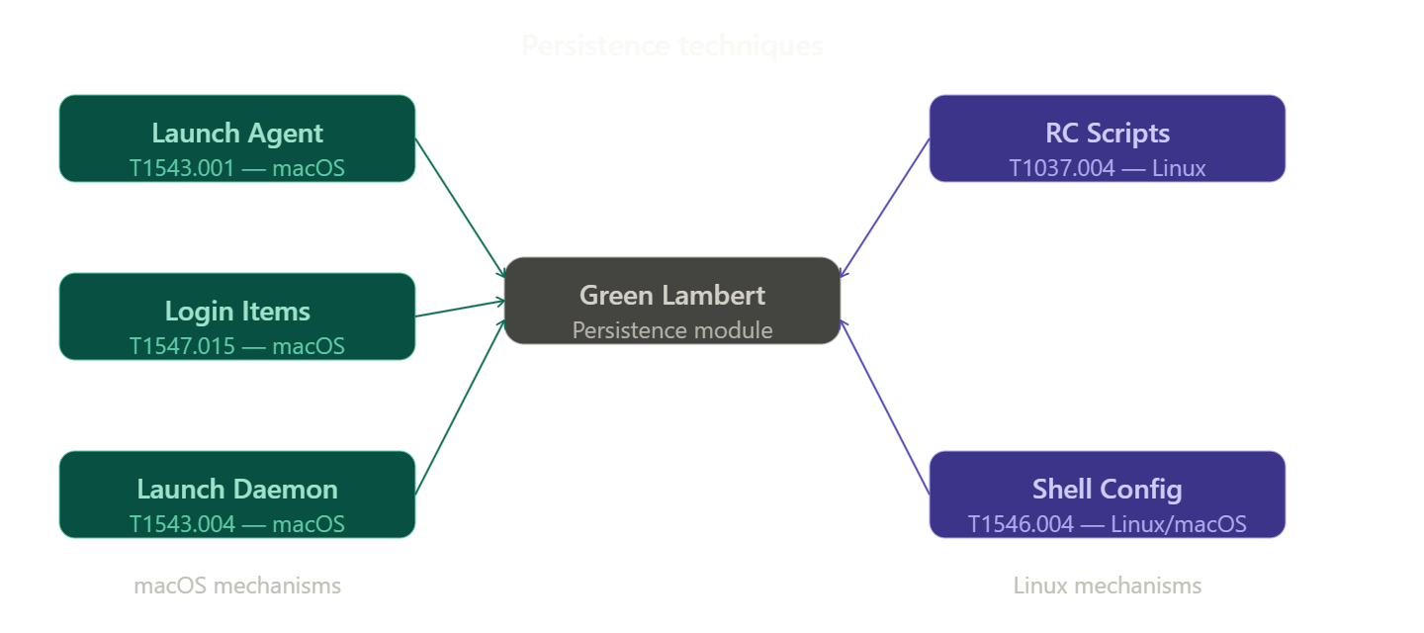
Green Lambert deploys multiple persistence mechanisms simultaneously across both macOS and Linux platforms, ensuring long-term access even if one method is discovered.
On macOS, it creates a Launch Agent (com.apple.GrowlHelper.plist) with RunAtLoad = true, adds itself as a Login Item, and installs a Launch Daemon — all ensuring automatic execution at login or startup. On Linux, it modifies /etc/init.d and /etc/rc.d via RC Scripts, and alters shell configuration files including .bash_profile and .login for bash, csh, and tcsh shells.
This combination of five persistence mechanisms across two operating systems makes Green Lambert extremely difficult to fully remove without a complete system reinstallation.

8. Privilege Escalation
Detail | Explanation
Launch Daemon | Requires and implies root level access for installation
No explicit escalation | Green Lambert assumes it is deployed with sufficient privileges
Implication | Initial access vector likely already provides elevated privileges

9. Defense Evasion
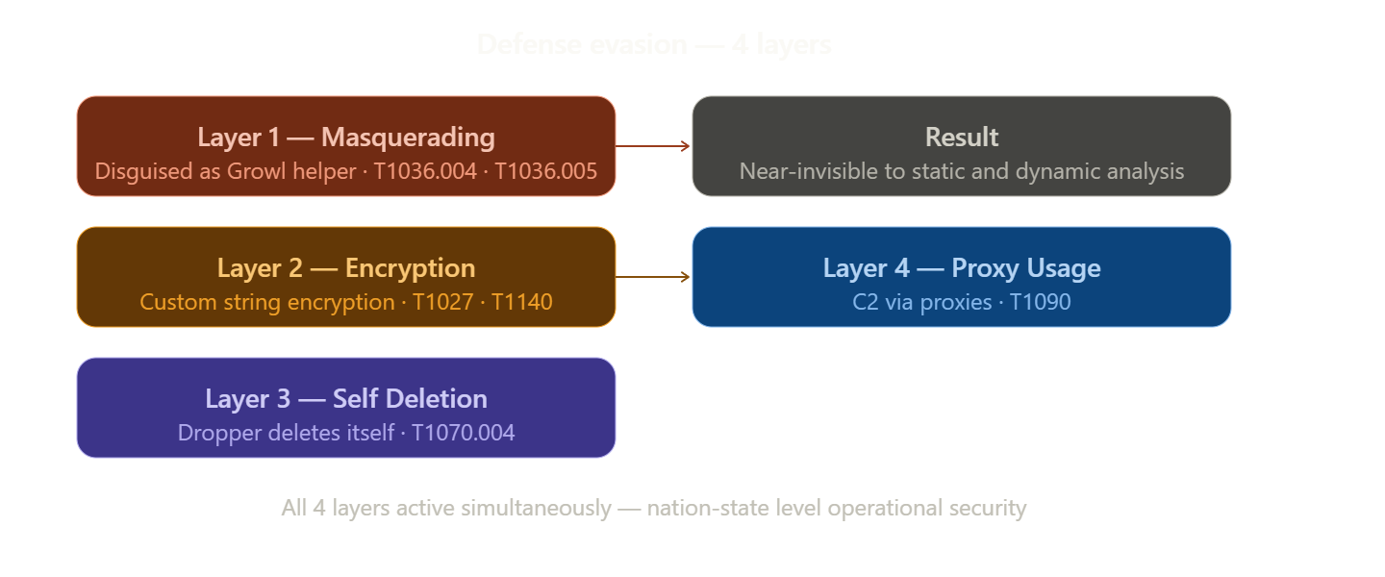
Green Lambert uses multiple layers of defense evasion:
Layer 1 — Masquerading
- Disguises itself as Growl notification helper — a legitimate macOS app
- Creates executable named "Software Update Check" to appear legitimate
- Uses plist name com.apple.GrowlHelper.plist mimicking Apple system files
- Techniques: T1036.004, T1036.005
Layer 2 — Encryption
- Uses multiple custom encryption routines to decrypt strings only at runtime
- Static analysis of the binary reveals no readable strings
- Technique: T1027, T1140
Layer 3 — Self Deletion
- Deletes its original executable after installation
- Removes evidence of initial dropper from disk
- Technique: T1070.004
Layer 4 — Proxy Usage
- Routes C2 traffic through proxies
- Makes traffic appear to originate from legitimate sources
- Technique: T1090

10.Credential Access

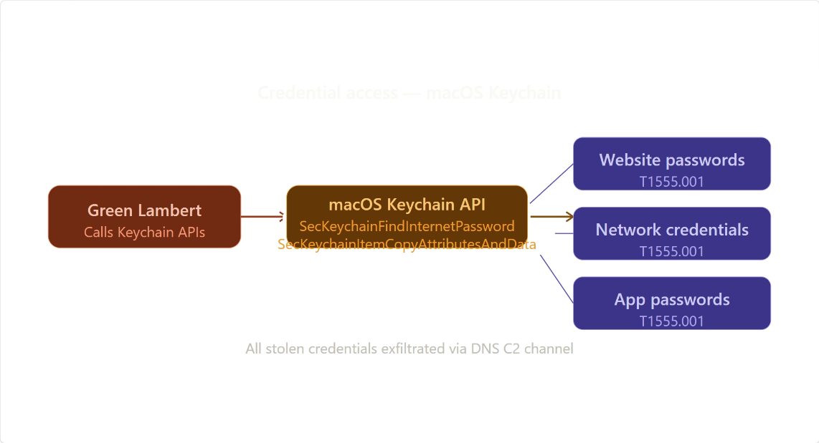
Method | Technique | Detail
macOS Keychain | T1555.001 | Uses SecKeychainFindInternetPassword API to extract stored passwords
Keychain Item Data | T1555.001 | Uses SecKeychainItemCopyAttributesAndData to copy credential data
What This Means
- macOS stores passwords in a system called Keychain
- Green Lambert calls Apple's own Keychain API functions to extract:
  - Website passwords
  - Network credentials
  - Application passwords
- This is particularly dangerous because Keychain holds all saved passwords

11. Discovery Techniques
Green Lambert deploys several discovery techniques to profile the compromised host and gather essential system information prior to establishing full C2 communication.
What It Discovers | Technique | Method
OS Information | T1082 | Deploys the uname command to collect OS name, version, and processor type
Network Configuration | T1016 | Reads system environment variables to obtain proxy settings of the host
System Time | T1124 | Collects current date and time from the compromised host

12. Lateral Movement
Green Lambert does not deploy any explicitly documented lateral movement techniques of its own. However, its modular architecture allows it to load additional plugins that may include lateral movement capabilities. It also deploys proxy tunneling (T1090) which can be used to route traffic through compromised hosts, enabling indirect lateral access. As a nation-state grade implant, lateral movement is assessed to be handled by companion tools deployed alongside Green Lambert rather than by the backdoor itself.
Detail | Explanation
Not Explicitly Documented | No specific lateral movement technique listed in MITRE ATT&CK
Modular Architecture | Deploys plugins that may include lateral movement capability
Proxy Usage | T1090 — deploys proxy tunneling through compromised hosts
Assessment | Lateral movement likely handled by companion tools
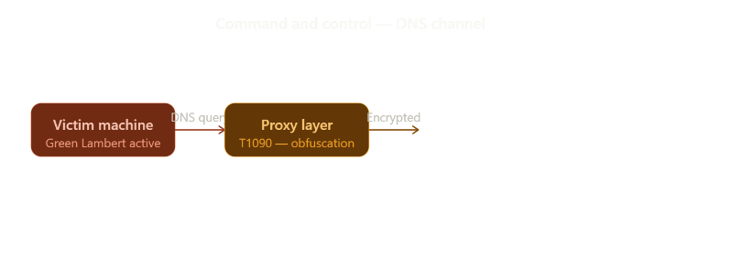
13. Command & Control (C2)

Green Lambert deploys DNS as its primary command and control channel (T1071.004), encoding commands and data inside DNS queries and responses. This makes detection significantly harder as DNS traffic is rarely blocked by firewalls and blends naturally with normal network activity. Additionally, it deploys proxy routing (T1090) to obfuscate all C2 communications, making traffic appear to originate from legitimate sources rather than the compromised host.
Method | Technique | Detail
DNS | T1071.004 | Primary C2 channel — deploys DNS queries for all communications
Proxy | T1090 | Deploys proxy routing to obfuscate C2 traffic

14. Exfiltration
Green Lambert deploys a two-stage exfiltration process. It first collects data from the local system (T1005) including system information, credentials harvested from the macOS Keychain, and sensitive local files. All collected data is then exfiltrated through its primary DNS-based C2 channel (T1071.004), encoding the stolen data inside DNS queries and responses to avoid detection.
Method | Technique | Detail
Collection | T1005 | Deploys local system data collection — files, credentials, system info
Exfiltration Channel | T1071.004 | Deploys DNS-based C2 channel to transmit stolen data
Proxy Obfuscation | T1090 | Routes exfiltrated data through proxies to avoid detection
What is Stolen | — | System info, Keychain credentials, sensitive local files

15. Impact Analysis
Green Lambert deploys a range of capabilities that result in significant and long-lasting impact on compromised systems. As a nation-state grade implant, its primary impact is intelligence collection and long-term covert access rather than destruction or disruption.
Impact Type | Technique | Detail
Espionage | T1005 | Deploys long-term stealthy access for sustained intelligence collection
Credential Theft | T1555.001 | Deploys complete macOS Keychain extraction — all saved passwords compromised
Data Theft | T1005 | Deploys collection of sensitive local files and system information
Persistent Access | T1543.001, T1547.015 | Deploys multiple persistence mechanisms ensuring long-term foothold
Stealth | T1070.004, T1027 | Deploys self deletion and encryption making detection extremely difficult
Longevity | — | Potentially active undetected from 2008 to 2017 — over 9 years

16.Indicators of Compromise (IOCs)
Green Lambert deploys several identifiable artifacts across file system, behavioral, and network layers that can be used to detect and confirm a compromise.
File System IOCs
IOC | Detail
com.apple.GrowlHelper.plist | Deployed in ~/Library/LaunchAgents/ — key persistence indicator
Software Update Check | Executable deployed in unusual or unexpected directories
Modified .bash_profile | Unexpected malicious entries deployed in shell config files
Modified /etc/init.d | Unauthorized service entries deployed in Linux init directory
Modified /etc/rc.d | Unauthorized entries deployed in Linux RC script directory

17.Behavioral IOCs
IOC | Detail
Self-deleting executable | Process that deploys deletion of its own binary after execution
DNS C2 traffic | High volume or unusual DNS queries deployed from workstation
Keychain API calls | SecKeychainFindInternetPassword deployed from unsigned processes
Proxy environment variables | Unexpected proxy settings deployed in system environment

Network IOCs
IOC | Detail
Unusual DNS query patterns | High frequency DNS queries with encoded data deployed to C2
DNS queries to unusual domains | Especially non-standard TLDs used as C2 endpoints
Encrypted DNS traffic | DNS deployed over non-standard ports for obfuscation

Detection & Mitigation
Green Lambert's sophisticated evasion techniques make detection challenging, however several behavioral and network indicators can be monitored to identify and mitigate its presence.
Detection Methods
Method | Technique | Detail
Launch Agent Monitoring | T1543.001 | Alert on creation of new plist files deployed in LaunchAgents folder
DNS Traffic Analysis | T1071.004 | Monitor for unusual DNS query patterns or high entropy domains
Keychain API Monitoring | T1555.001 | Alert on unsigned processes deploying Keychain API calls
Shell Config Monitoring | T1546.004 | Detect modifications deployed to .bash_profile and .login files
Self-Deleting Process | T1070.004 | Alert on processes that deploy deletion of their own binary
File Integrity Monitoring | T1037.004 | Monitor /etc/init.d and /etc/rc.d for unauthorized changes
Proxy Traffic Analysis | T1090 | Monitor for unexpected proxy settings deployed in system environment

Mitigation Methods
Method | Detail
Gatekeeper | Deploy macOS Gatekeeper to block unsigned and untrusted applications
DNS Filtering | Deploy DNS filtering solution to identify and block C2 domains
Endpoint Detection | Deploy EDR solution with behavioral detection capability
Keychain Protection | Deploy Keychain access alerts for all applications requesting credentials
System Integrity Protection | Deploy macOS SIP to prevent unauthorized system file modification
Network Monitoring | Deploy DNS traffic analysis tools such as Zeek or Suricata
Application Whitelisting | Deploy application whitelisting to block unknown executables
Overall Defensive Posture
18. Research and sources
Given Green Lambert's nation-state level sophistication, a layered defensive approach is essential. No single mitigation is sufficient organizations must deploy detection at the file system, behavioral, network, and endpoint levels simultaneously to have any reasonable chance of identifying this implant before significant damage occurs.
 | Author | Title | Year | Source
1 | Kaspersky GReAT | Unraveling the Lamberts Toolkit | 2017 | https://securelist.com/unraveling-the-lamberts-toolkit/77990/
2 | Sandvik, R. | Made In America: Green Lambert for OS X | 2021 | https://objective-see.com/blog/blog_0x68.html
3 | Sandvik, R. | Green Lambert and ATT&CK | 2021 | https://www.glitch-cat.com/blog/green-lambert-and-attack
4 | MITRE ATT&CK | S0690 — Green Lambert | 2022 | https://attack.mitre.org/software/S0690/

S0691 — Whirlpool
Intern ID: 2169 | Campaign: C0022 Operation Dream Job
1. Name & Type
Field | Detail
Name | Whirlpool
ATT&CK ID | S0691
Type | Malware — Backdoor (TLS Reverse Shell)
File Type | 32-bit ELF Linux Binary
First Identified | August 2023
Identified By | CISA

2. Description
Whirlpool is a Linux backdoor discovered by CISA during investigation of attacks targeting Barracuda Email Security Gateway (ESG) appliances. It was deployed by the China-nexus threat group UNC4841 who exploited critical zero-day vulnerability CVE-2023-2868 (CVSS 9.8) in Barracuda ESG devices.
The malware establishes an encrypted TLS reverse shell to an attacker-controlled C2 server, accepting the C2 IP address and port number as runtime arguments — meaning no C2 address is hardcoded in the binary, making static analysis less effective. It was found named "ssld" — deliberately mimicking the legitimate OpenSSL helper process.
3. Threat Actor Association
Field | Detail
Threat Actor | UNC4841
Origin | 🇨🇳 China — assessed China-nexus espionage actor
Sponsor | Assessed to support Chinese state interests
Motivation | Cyber Espionage — intelligence collection
Active Since | At least October 2022
Other Tools Used | Seaspray, Saltwater, Seaside backdoors

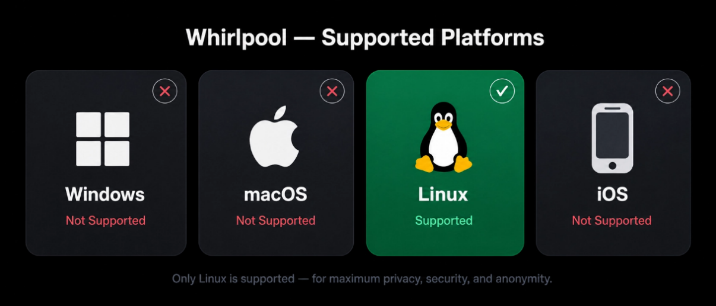
Linus yes windows no mac os no ios no

5. ATT&CK Techniques Used
Tactic | ID | Technique Name
Initial Access | T1190 | Exploit Public-Facing Application
Execution | T1059.004 | Command and Scripting: Unix Shell
Defense Evasion | T1036.005 | Masquerading: Match Legitimate Resource
Command & Control | T1071.001 | Application Layer Protocol: Web Protocols
Command & Control | T1573 | Encrypted Channel
Command & Control | T1571 | Non-Standard Port

6. Execution Method
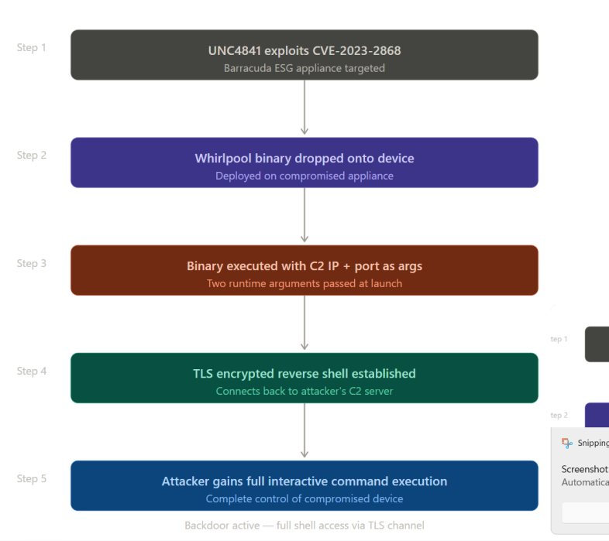

7. Persistence Techniques
Detail | Explanation
No standalone persistence | Whirlpool itself does not implement persistence
Relies on broader toolset | UNC4841 uses Seaspray as primary persistent backdoor
Saltwater module | Persistent SMTP daemon module used alongside Whirlpool
Assessment | Whirlpool is deployed as a secondary access tool

8. Privilege Escalation
Whirlpool does not deploy explicit privilege escalation techniques. The underlying CVE-2023-2868 exploit provides root-level command injection on the ESG appliance, meaning Whirlpool assumes elevated access from the moment of deployment.
Detail | Explanation
CVE-2023-2868 | Exploit deploys root-level command injection on ESG
CVSS Score | 9.8 — Critical severity
No Explicit Escalation | Whirlpool assumes root access from the exploit
9. Defense Evasion
Whirlpool deploys several layers of defense evasion making it difficult to detect through both static and network-based analysis.
Layer | Technique | Detail
Masquerading | T1036.005 | Binary named "ssld" to mimic legitimate OpenSSL daemon process
Encrypted Channel | T1573 | All C2 traffic encrypted with TLS — identical to legitimate HTTPS
Runtime Arguments | — | No hardcoded C2 IP — provided at runtime, static analysis ineffective
Trusted Device Targeting | — | Deployed on email security gateways — often excluded from monitoring
10. Credential Access
Whirlpool does not deploy direct credential theft techniques. However the broader UNC4841 campaign involved exfiltration of email data and credentials from compromised ESG appliances, leveraging the privileged position of the email gateway in the network.
Detail | Explanation
No Direct Credential Theft | Whirlpool itself deploys no credential access modules
Email Gateway Access | Compromising ESG provides access to all email communications
Broader Campaign | UNC4841 exfiltrated email data and credentials from ESG devices
11. Discovery Techniques
Whirlpool does not deploy automated discovery modules. All post-exploitation discovery is conducted manually by the operator through the interactive TLS reverse shell.
Detail | Explanation
Interactive Shell | TLS reverse shell deploys full manual command execution
No Automated Discovery | Whirlpool deploys no built-in discovery modules
Manual Enumeration | Operator manually deploys discovery commands via shell
12. Lateral Movement
Whirlpool itself does not deploy lateral movement techniques. However its privileged position on the ESG appliance — which sits between the internet and internal mail servers — makes it an ideal pivot point for lateral movement into the internal network.
Detail | Explanation
No Direct Lateral Movement | Whirlpool deploys no built-in lateral movement capability
Strategic Position | ESG sits between internet and internal network — prime pivot point
UNC4841 Campaign | Broader campaign observed pivoting from ESG to internal networks
13. Command & Control (C2)
Whirlpool deploys a TLS-encrypted reverse shell as its sole C2 mechanism. All communications are encrypted making network-layer detection extremely difficult without SSL inspection capabilities.
Method | Technique | Detail
TLS Reverse Shell | T1573 | Deploys fully encrypted TLS channel for all C2 communications
Web Protocols | T1071.001 | Traffic mimics legitimate HTTPS communications
Non-Standard Port | T1571 | Port number deployed at runtime — can use any port
14. Exfiltration
Whirlpool deploys exfiltration through its TLS reverse shell channel. The broader UNC4841 campaign involved extraction of sensitive government communications and email metadata from compromised ESG appliances across 16+ countries.
Method | Technique | Detail
Exfiltration Channel | T1573 | Deploys TLS reverse shell for data exfiltration
What is Stolen | — | Email metadata, sensitive government communications
Scope | — | 16+ countries affected across government and defence sectors
15. Impact Analysis
Whirlpool enables full remote command execution on compromised ESG appliances. Its deployment as part of the UNC4841 campaign had significant espionage impact across government and defence sectors globally.
Impact Type | Technique | Detail
Remote Command Execution | T1059.004 | Full interactive shell access on compromised ESG device
Email Interception | T1190 | All emails passing through ESG potentially intercepted
Espionage | T1573 | Sensitive government communications exfiltrated
Strategic Positioning | — | ESG compromise provides pivot point into internal networks
Global Reach | — | 16+ countries affected — government, defence, aviation, energy sectors
16. Indicators of Compromise (IOCs)
File System IOCs
IOC | Detail
File name: ssld | Deployed in unexpected paths — not legitimate OpenSSL location
SHA256 | 0af253e60456b03af49cc675f71d47b2dd9a48f50a927e43b9d8116985c06459
MD5 | 77e1e9bf69b09ed0840534adb8258540
ELF binary | 32-bit ELF binary deployed on ESG appliance

Behavioral IOCs
IOC | Detail
Unexpected child processes | Unusual processes spawned from Barracuda SMTP service
Runtime argument execution | Binary executed with two IP/port arguments
Outbound TLS connections | ESG appliance deploying TLS connections to unusual external IPs

Network IOCs
IOC | Detail
Outbound TLS from ESG | Unexpected TLS sessions from email gateway to external IPs
Non-standard ports | TLS connections deployed to unusual or non-standard ports
CVE-2023-2868 | Exploitation activity on Barracuda ESG versions 5.1.3.001–9.2.0.006
17. Detection & Mitigation
Detection Methods
Method | Technique | Detail
ESG Process Monitoring | T1059.004 | Monitor for unexpected child processes on ESG appliances
Outbound TLS Monitoring | T1573 | Alert on TLS connections from ESG to unusual external IPs
File Integrity Monitoring | T1036.005 | Detect binaries named ssld deployed outside legitimate paths
Network Anomaly Detection | T1571 | Alert on TLS sessions deployed to non-standard ports from ESG
CVE Patching | T1190 | Apply Barracuda ESG patches — replace compromised hardware

Mitigation Methods
Method | Detail
Hardware Replacement | CISA recommends replacing compromised Barracuda ESG hardware entirely
Network Segmentation | Deploy network segmentation to limit ESG pivot access
SSL Inspection | Deploy TLS inspection to detect encrypted reverse shells
Threat Intelligence | Subscribe to UNC4841 IOC feeds for C2 domain blocking
EDR on Appliances | Deploy behavioral monitoring on email security appliances

18. References & Sources
# | Author | Title | Year | Source
1 | CISA | MAR-10459736 WHIRLPOOL Backdoor | 2023 | https://www.cisa.gov/
2 | Mandiant | Barracuda ESG Exploitation — UNC4841 | 2023 | https://www.mandiant.com/
3 | BleepingComputer | New Whirlpool Backdoor Used in Barracuda ESG Hacks | 2023 | https://www.bleepingcomputer.com/
4 | MITRE ATT&CK | S0691 — Whirlpool | 2023 | https://attack.mitre.org/software/S0691/

S0692 — SILENTTRINITY
1. Name & Type
Field | Detail
Name | SILENTTRINITY
ATT&CK ID | S0692
Type | Tool — Open Source Post-Exploitation Framework
Language | Python, Boo, PowerShell, C
First Identified | 2019
Identified By | Security researcher byt3bl33d3r
2. Description
SILENTTRINITY is an open-source post-exploitation and C2 framework that loads the Common Language Runtime (CLR) into arbitrary processes for in-memory .NET execution, bypassing traditional script-based detection. It supports an extensive module library covering keylogging, credential dumping, lateral movement, UAC bypass, and anti-forensics. It was observed in the wild against Croatian government targets in 2019.
3. Threat Actor Association
Field | Detail
Threat Actor | Unidentified cyber actors
Confirmed Use | Croatian government attack 2019
Availability | Publicly available open-source tool
Motivation | Espionage, financial gain
4. Supported Platforms
Platform | Supported
Windows | Yes
Linux | No
macOS | No

5. ATT&CK Techniques Used
Tactic | ID | Technique Name
Privilege Escalation | T1548.002 | Bypass UAC
Privilege Escalation | T1134.001 | Token Impersonation/Theft
Persistence | T1547.001 | Registry Run Keys / Startup Folder
Persistence | T1543.003 | Windows Service
Persistence | T1546.003 | WMI Event Subscription
Execution | T1059.001 | PowerShell
Execution | T1059.003 | Windows Command Shell
Collection | T1115 | Clipboard Data
Credential Access | T1555.003 | Credentials from Web Browsers
Credential Access | T1003.001 | LSASS Memory
Credential Access | T1558.003 | Kerberoasting
Defense Evasion | T1685 | Disable or Modify Tools — AMSI bypass
Defense Evasion | T1620 | Reflective Code Loading
Lateral Movement | T1021.003 | DCOM
Lateral Movement | T1021.006 | WinRM
Exfiltration | T1041 | Exfiltration Over C2 Channel
6. Execution Method
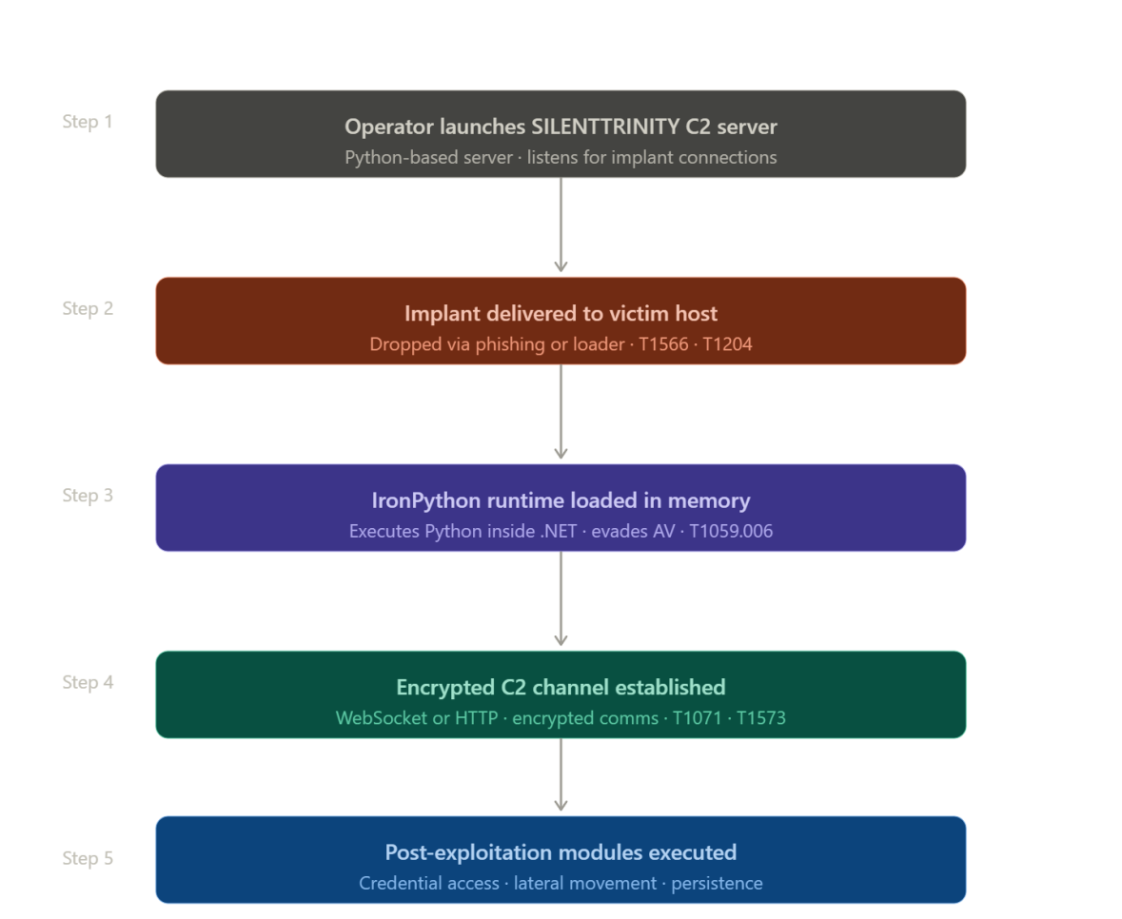
7. Persistence Techniques
SILENTTRINITY deploys multiple persistence mechanisms to ensure long-term access on compromised Windows systems.
Mechanism | Technique | Detail
Registry Run Keys | T1547.001 | Deploys LNK file in startup folder
Windows Service | T1543.003 | Deploys new service for persistence
WMI Event Subscription | T1546.003 | Deploys WMI event for payload execution
COM Hijacking | T1546.015 | Deploys CLSID registry key modification

8.Privilege Escalation
Method | Technique | Detail
UAC Bypass | T1548.002 | Deploys Device Manager and .msc file extension hijack
Token Impersonation | T1134.001 | Deploys token theft from target user processes
Make and Impersonate Token | T1134.003 | Deploys token creation from known credentials
AlwaysInstallElevated | — | Checks registry keys for MSI privilege escalation
9. Defense Evasion
SILENTTRINITY deploys multiple evasion techniques making it extremely difficult to detect through standard Windows security controls.
10. Credential Access
Method | Technique | Detail
LSASS Dump | T1003.001 | Deploys MiniDumpWriteDump to extract LSASS memory
Browser Credentials | T1555.003 | Deploys IE/Edge cleartext credential collection
Credential Manager | T1555.004 | Deploys Windows Vault enumeration
Kerberoasting | T1558.003 | Deploys Kerberoasting attack module
GPP Passwords | T1552.006 | Deploys GPP cached password extraction
Credential Phishing | T1056.002 | Deploys GUI prompt via credphisher.py
11. Discovery Techniques
What It Discovers | Technique | Method
System Information | T1082 | Deploys OS version and system info collection
User Enumeration | T1033 | Deploys user and session enumeration
Network Ports | T1046 | Deploys network port scanning
Network Shares | T1135 | Deploys network share enumeration
Running Processes | T1057 | Deploys process enumeration including CLR detection
Registry | T1012 | Deploys registry querying

12. Lateral Movement
Method | Technique | Detail
DCOM | T1021.003 | Deploys System namespace methods for lateral movement
WinRM | T1021.006 | Deploys TrustedHosts enumeration for WinRM access
WMI | T1047 | Deploys WMI remote execution
Process Injection | T1055 | Deploys injection into target processes

13. Command & Control (C2)
SILENTTRINITY deploys a Python-based team server with agents communicating over HTTP/HTTPS. All data is exfiltrated back through the C2 channel.
Method | Technique | Detail
HTTP/HTTPS | T1071.001 | Deploys web protocol based C2 communications
Exfiltration over C2 | T1041 | Deploys data transfer back to team server
14. Exfiltration
Method | Technique | Detail
C2 Channel | T1041 | Deploys file transfer from host to C2 server
Screen Capture | T1113 | Deploys screenshot collection before exfiltration
Keylogging | T1056.001 | Deploys keystroke capture for intelligence collection
15. Impact Analysis
Impact Type | Technique | Detail
Complete Credential Compromise | T1003.001 | LSASS dump provides all domain credentials
Lateral Movement | T1021.003 | Full domain-wide lateral movement capability
Persistent Access | T1547.001 | Multiple persistence mechanisms deployed
Defense Bypass | T1685 | AMSI and logging bypassed — standard defenses ineffective
Data Exfiltration | T1041 | Full file and credential exfiltration capability
16. IOCs
Type | IOC | Detail
File | Startup folder LNK file | Created by unusual non-user processes
Registry | HKCU\Software\Classes\CLSID | COM hijacking via CLSID modification
Behavioral | AMSI bypass patterns | AmsiScanBuffer patch in memory
Behavioral | MiniDumpWriteDump calls | From non-system processes targeting LSASS
Network | HTTP beaconing | Regular beaconing to C2 team server
17. Detection & Mitigation
Method | Detail
PowerShell Logging | Enable ScriptBlock logging and AMSI telemetry
LSASS Protection | Alert on MiniDumpWriteDump from non-system processes
WMI Monitoring | Monitor WMI event subscription creation
COM Hijacking Detection | Alert on CLSID modifications in HKCU
Behavioral Analytics | Deploy token impersonation pattern detection
CLR Monitoring | Hunt for CLR loading into non-.NET processes
18. References
# | Source | Year | Link
1 | Salvati, M. — SILENTTRINITY GitHub | 2019 | https://github.com/byt3bl33d3r/SILENTTRINITY
2 | Security Affairs — Croatia Government Attack | 2019 | https://securityaffairs.co/
3 | MITRE ATT&CK S0692 | 2022 | https://attack.mitre.org/software/S0692/
S0693 — CaddyWiper
1. Name & Type
Field | Detail
Name | CaddyWiper
ATT&CK ID | S0693
Type | Malware — Destructive Data Wiper
First Identified | March 14, 2022
Identified By | ESET Research
2. Description
CaddyWiper is a destructive data wiper deployed by Sandworm Team against Ukrainian organizations during the Russo-Ukrainian War. It systematically overwrites all files alphabetically across all drive letters, then destroys disk partition structures including the MBR and GPT, rendering systems completely unbootable. It notably skips domain controllers to preserve network infrastructure.
3. Threat Actor Association
Field | Detail
Threat Actor | Sandworm Team
ATT&CK ID | G0034
Origin | 🇷🇺 Russia — GRU Military Intelligence
Motivation | Destructive cyber warfare
Target | Ukrainian organizations — 2022
4. Supported Platforms
Platform | Supported
Windows | Yes
Linux | No
ATT&CK Techniques Used
Tactic | ID | Technique Name
Impact | T1485 | Data Destruction
Impact | T1561.002 | Disk Wipe: Disk Structure Wipe
Discovery | T1083 | File and Directory Discovery
Defense Evasion | T1222.001 | File Permissions Modification
Execution | T1106 | Native API
Discovery | T1057 | Process Discovery
Discovery | T1082 | System Information Discovery
6. Execution Method

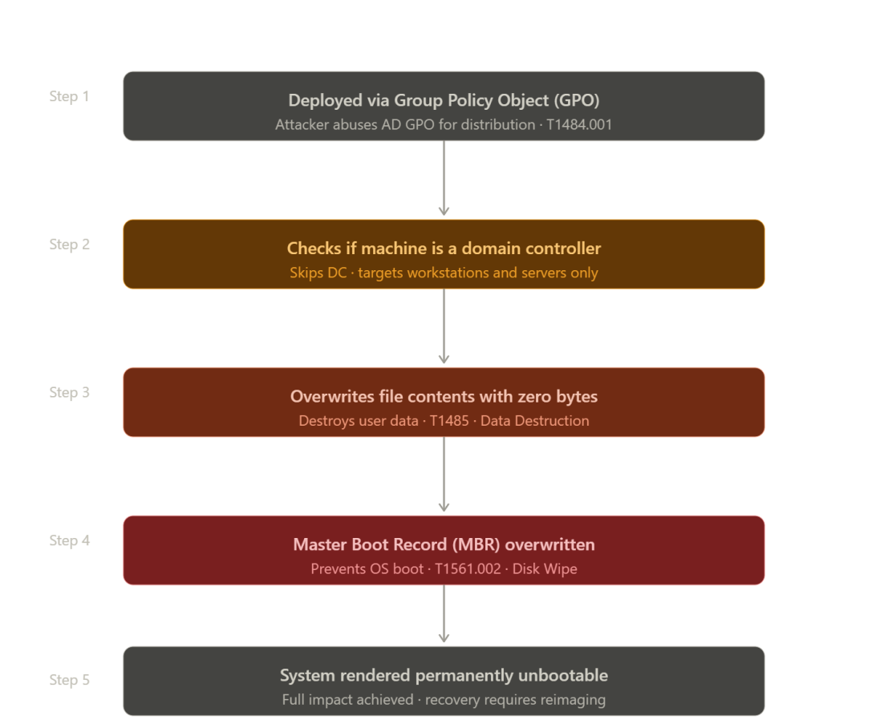
7. Persistence Techniques
CaddyWiper deploys no persistence mechanisms. It is a single-use destructive payload designed to destroy the system it runs on.
8. Privilege Escalation
Detail | Explanation
SeTakeOwnershipPrivilege | Deployed to take ownership of all files
GPO Deployment | Deployed via domain GPO implying domain admin level access
No Explicit Escalation | Assumes administrative privileges at deployment
9. Defense Evasion
Method | Technique | Detail
Dynamic API Resolution | T1106 | Deploys runtime API resolution — harder to detect statically
Domain Controller Skip | T1082 | Checks DC role via DsRoleGetPrimaryDomainInformation before wiping
10. Credential Access
CaddyWiper deploys no credential access capabilities. It is a pure destructive payload with no intelligence gathering functionality.
11. Discovery Techniques
What It Discovers | Technique | Method
Files and Directories | T1083 | Deploys enumeration of all files across all drive letters
Running Processes | T1057 | Deploys process list enumeration
Domain Role | T1082 | Deploys DsRoleGetPrimaryDomainInformation to identify DCs
12. Lateral Movement
CaddyWiper deploys no lateral movement. In the 2022 Ukraine Electric Power Attack, Sandworm used GOGETTER and Neo-REGEORG for lateral movement before deploying CaddyWiper.
13. Command & Control
CaddyWiper deploys no C2 functionality. It is a standalone destructive payload distributed via GPO.
14. Exfiltration
CaddyWiper deploys no exfiltration capability. It is a pure destruction tool, not an intelligence gathering implant.
15. Impact Analysis
Impact Type | Technique | Detail
Data Destruction | T1485 | All files overwritten — completely irreversible
System Destruction | T1561.002 | MBR and GPT destroyed — system unbootable
Operational Disruption | — | Used against Ukrainian electric utility during active conflict
Recovery Difficulty | — | Full system reinstallation required for recovery
16. IOCs
Type | IOC | Detail
Behavioral | DsRoleGetPrimaryDomainInformation calls | Wiper checking for DC role before execution
Behavioral | Mass file ownership changes | Bulk ACL modifications across all drive letters
Behavioral | Raw disk writes to sector 0 | MBR/GPT destruction pattern
Network | GPO deployment | Unauthorized GPO linking across domain
17. Detection & Mitigation
Method | Detail
GPO Monitoring | Monitor for unauthorized GPO linking or startup script additions
Raw Disk Write Detection | Alert on processes writing to disk sector 0
Mass ACL Monitoring | Alert on abnormal bulk file ownership changes
Application Whitelisting | Prevent execution of unknown executables deployed via GPO
18. References
# | Source | Year | Link
1 | ESET Research — CaddyWiper | 2022 | https://www.welivesecurity.com/
2 | Cisco Talos — CaddyWiper Advisory | 2022 | https://blog.talosintelligence.com/
3 | MITRE ATT&CK S0693 | 2022 | https://attack.mitre.org/software/S0693/

S0694 — DRATzarus
1. Name & Type
Field | Detail
Name | DRATzarus
ATT&CK ID | S0694
Type | Malware — Remote Access Trojan (RAT)
Platform | Windows
First Identified | Summer 2020
Identified By | ClearSky, McAfee, ESET
2. Description
DRATzarus is a Windows RAT developed and used by Lazarus Group to target defence and aerospace organizations globally since at least summer 2020. It shares code similarities with Bankshot malware. Identified in Operation Dream Job, it uses fake job recruitment lures targeting defence sector employees. Its dropper is packed with UPX and named 'IExplorer' to evade detection.
3. Threat Actor Association
Field | Detail
Threat Actor | Lazarus Group
ATT&CK ID | G0032
Origin | 🇰🇵 North Korea — RGB Bureau 121
Campaign | Operation Dream Job / Operation North Star
Motivation | Espionage + Financial gain
4. Supported Platforms
Platform | Supported
Windows | Yes
Linux | No
macOS | No
5. ATT&CK Techniques Used
Tactic | ID | Technique Name
C2 | T1071.001 | Application Layer Protocol: Web Protocols
Collection | T1005 | Data from Local System
Defense Evasion | T1622 | Debugger Evasion
Execution | T1105 | Ingress Tool Transfer
Defense Evasion | T1036.005 | Masquerading
Execution | T1106 | Native API
Defense Evasion | T1027 | Obfuscated Files
Defense Evasion | T1027.002 | Software Packing — UPX
Discovery | T1057 | Process Discovery
Discovery | T1018 | Remote System Discovery
Discovery | T1033 | System Owner/User Discovery
Discovery | T1124 | System Time Discovery
Defense Evasion | T1497.003 | Time Based Sandbox Evasion
- Execution Method
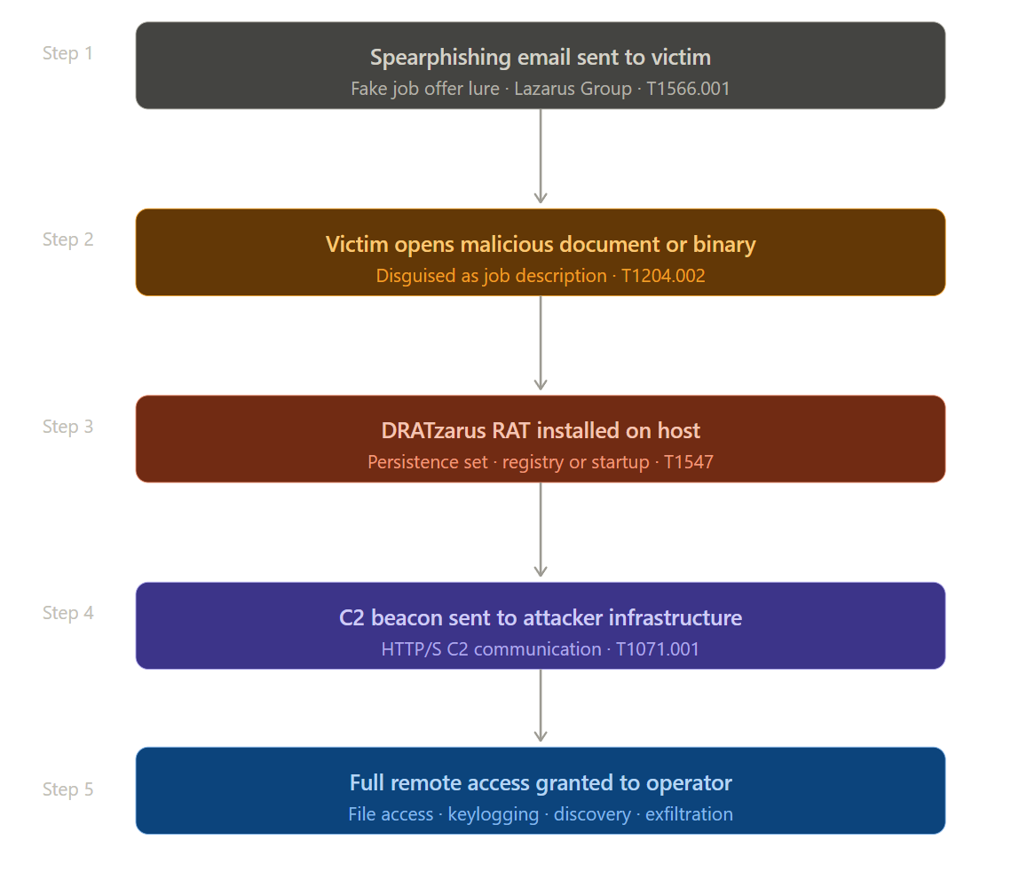
7. Persistence Techniques
DRATzarus relies on the broader Lazarus Group infection chain for persistence. No specific standalone persistence mechanisms are documented in MITRE for DRATzarus itself.
8. Privilege Escalation
No specific privilege escalation techniques documented. DRATzarus assumes sufficient privileges via the initial spearphishing infection vector.
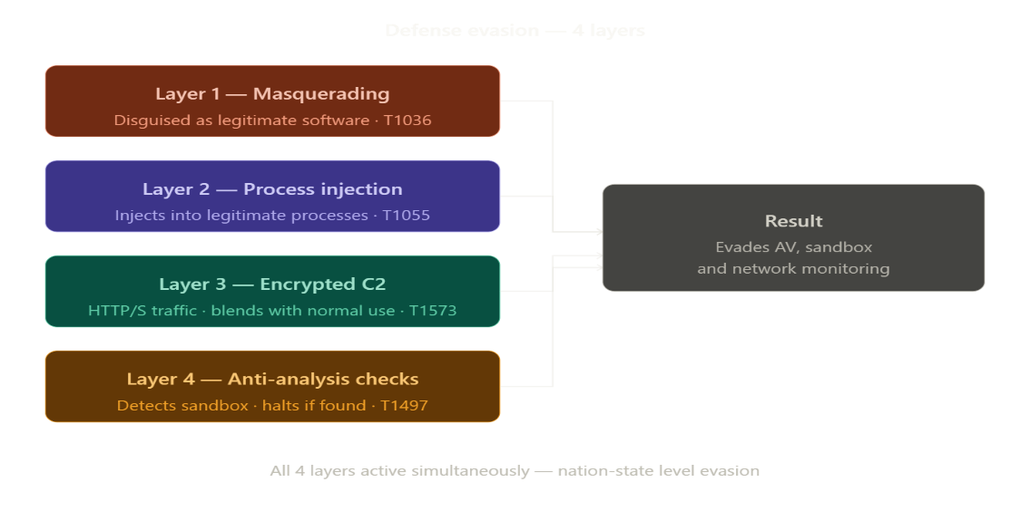
9. Defense Evasion

10. Credential Access
DRATzarus does not deploy direct credential theft. However Lazarus Group operations typically include credential harvesting tools deployed via DRATzarus ingress tool transfer (T1105).
11. Discovery Techniques
What It Discovers | Technique | Method
Running Processes | T1057 | Deploys process enumeration for debugger detection
Network Topology | T1018 | Deploys remote system discovery and network mapping
System Users | T1033 | Deploys user enumeration on compromised host
System Time | T1124 | Deploys timing queries for sandbox evasion
12. Lateral Movement
Method | Technique | Detail
Network Mapping | T1018 | Deploys network topology discovery for pivot planning
Tool Deployment | T1105 | Deploys additional lateral movement tools
Follow-on Tools | — | Responder and Wake-On-LAN deployed via DRATzarus
13. Command & Control
Method | Technique | Detail
HTTP/HTTPS | T1071.001 | Deploys web protocol based C2 communications
Legitimate Domains | — | Lazarus deploys legitimate-looking domains for C2

14. Exfiltration
Method | Technique | Detail
C2 Channel | T1071.001 | Deploys HTTP/HTTPS channel for data exfiltration
Local Collection | T1005 | Deploys local system data collection before exfiltration
15. Impact Analysis
Impact Type | Detail
Espionage | Provides Lazarus Group persistent access to defence networks
IP Theft | Defence and aerospace intellectual property targeted
Network Mapping | Full network topology exposed to attacker
Follow-on Attacks | Platform for deploying additional destructive or espionage tools
16. IOCs
Type | IOC | Detail
File | Flash.exe | Payload deployed with this name
File | IExplorer | UPX packed dropper name
Behavioral | IsDebuggerPresent API calls | Sandbox evasion check deployed at startup
Behavioral | GetTickCount timing sequences | Time-based sandbox evasion pattern
Network | HTTP beaconing | Regular C2 beacon from Flash.exe or IExplorer
17. Detection & Mitigation
Method | Detail
UPX Detection | Alert on UPX-packed executables from user-writable directories
Process Name Validation | Verify Flash.exe and IExplorer path and hash
Timing API Monitoring | Detect sandbox evasion API sequences
Network Monitoring | Alert on C2 beaconing patterns from new processes
Application Control | Block UPX-packed binaries from temp/download directories
18. References
# | Source | Year | Link
1 | ClearSky — Operation Dream Job | 2020 | https://www.clearskysec.com/
2 | McAfee — Operation North Star | 2020 | https://www.mcafee.com/
3 | ESET — Operation Interception | 2020 | https://www.welivesecurity.com/
4 | MITRE ATT&CK S0694 | 2022 | https://attack.mitre.org/software/S0694/

S0695 — Donut
1. Name & Type
Field | Detail
Name | Donut
ATT&CK ID | S0695
Type | Tool — Open Source Shellcode Generation Framework
Author | TheWover (@TheRealWover)
First Released | May 2019
2. Description
Donut is an open-source framework that generates position-independent shellcode from various executable formats including .NET assemblies, VBScript, JScript, EXE, and DLL files. It bypasses AMSI and WLDP at the module level, enabling in-memory execution of otherwise-blocked payloads. Evil Corp used Donut in the WastedLocker ransomware campaign in 2020.
3. Threat Actor Association
Field | Detail
Primary User | Indrik Spider / Evil Corp — WastedLocker ransomware 2020
Availability | Publicly available open-source tool
Other Users | Multiple ransomware groups and APTs
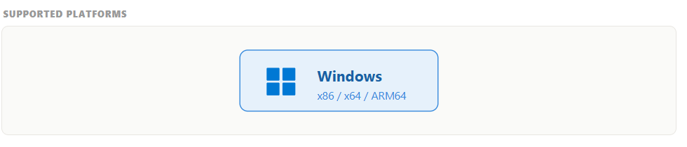
5. ATT&CK Techniques Used
Tactic | ID | Technique Name
C2 | T1071.001 | Web Protocols — HTTP payload staging
Execution | T1059.001 | PowerShell
Defense Evasion | T1685 | Disable or Modify Tools — AMSI/WLDP bypass
Defense Evasion | T1070 | Indicator Removal
Execution | T1105 | Ingress Tool Transfer
Execution | T1106 | Native API
Defense Evasion | T1027.002 | Software Packing
Defense Evasion | T1027.013 | Encrypted/Encoded File
Discovery | T1057 | Process Discovery
Defense Evasion | T1055 | Process Injection
Defense Evasion | T1620 | Reflective Code Loading
- Execution Method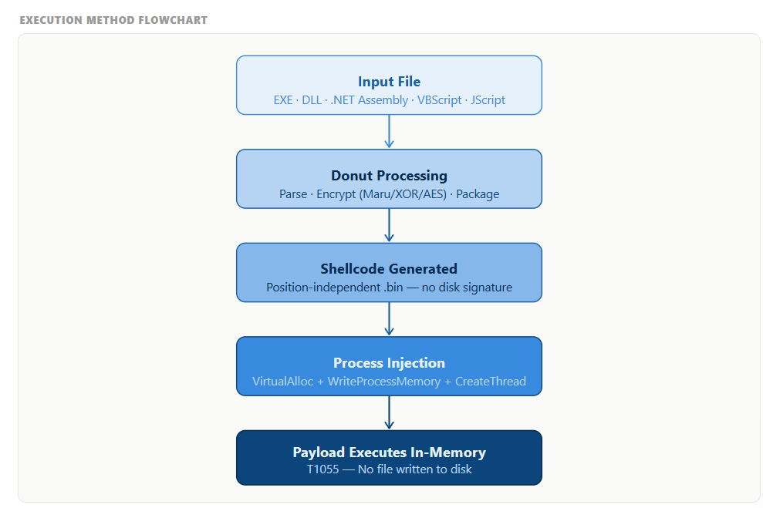
- Persistence Techniques
Donut deploys no persistence capabilities. It is a shellcode generation and loader tool only. Persistence is handled by the payload it delivers.
8. Privilege Escalation
Donut deploys no privilege escalation. Payloads loaded by Donut shellcode may include privilege escalation modules.
9. Defense Evasion
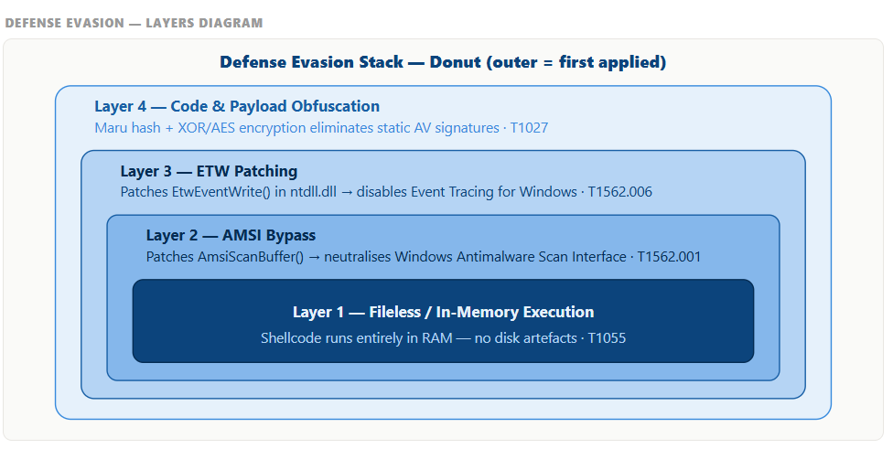
10. Credential Access
Donut deploys no credential access. Payloads delivered via Donut may include credential theft tools.
11. Discovery Techniques
What It Discovers | Technique | Method
Running Processes | T1057 | Deploys process enumeration for injection target selection
12. Lateral Movement
Donut deploys no lateral movement directly. It delivers post-exploitation frameworks such as Cobalt Strike that enable lateral movement.
13. Command & Control
Method | Technique | Detail
HTTP Staging | T1071.001 | Deploys HTTP download of shellcode from staging server
14. Exfiltration
Donut deploys no exfiltration. It is a delivery and loader mechanism only.
15. Impact Analysis
Impact Type | Detail
Force Multiplier | Enables memory-only payload execution with AMSI bypass
Ransomware Delivery | Used by Evil Corp in WastedLocker — significant financial losses
Widely Adopted | Open-source availability means any threat actor can deploy it
Defense Bypass | Renders standard Windows AMSI defenses ineffective
16. IOCs
Type | IOC | Detail
Behavioral | AMSI bypass API calls | AmsiScanBuffer patch deployed from unusual processes
Behavioral | WLDP bypass patterns | Windows Lockdown Policy bypass in memory
Behavioral | CLR loading | .NET runtime loaded into non-.NET processes
Network | Binary HTTP downloads | Shellcode downloaded without file extension
17. Detection & Mitigation
Method | Detail
AMSI Telemetry | Enable AMSI and alert on patching attempts
CLR Monitoring | Alert on CLR loading into non-.NET processes
Memory Scanning | Deploy shellcode pattern detection in memory
Network Monitoring | Alert on HTTP binary blob downloads from staging servers
Application Whitelisting | Block execution of unknown shellcode loaders
18. References
# | Source | Year | Link
1 | TheWover — Donut GitHub | 2019 | https://github.com/TheWover/donut
2 | NCC Group — WastedLocker | 2020 | https://research.nccgroup.com/
3 | MITRE ATT&CK S0695 | 2022 | https://attack.mitre.org/software/S0695/
S0696 — Flagpro
1. Name & Type
Field | Detail
Name | Flagpro
ATT&CK ID | S0696
Type | Malware — First-Stage Downloader
Platform | Windows
First Identified | October 2020
Identified By | NTT Security Holdings
2. Description
Flagpro is a Windows-based first-stage downloader attributed to BlackTech, a China-affiliated APT group. Deployed primarily against defence, media, and communications companies in Japan since October 2020. It communicates via HTTP to receive instructions and download second-stage payloads, establishing persistence and enabling follow-on malware deployment.
3. Threat Actor Association
Field | Detail
Threat Actor | BlackTech
Also Known As | Circuit Panda, HUAPI, Palmerworm, Red Djinn
Origin | 🇨🇳 China-nexus APT
Motivation | Cyber Espionage
Primary Targets | Japan — defence, media, communications
- Supported Platforms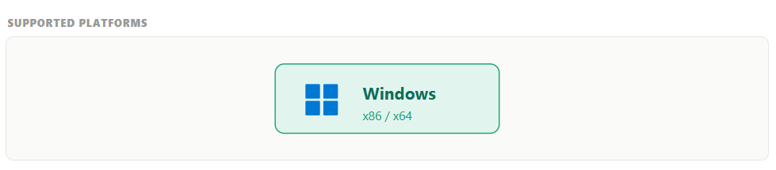
5. ATT&CK Techniques Used
Tactic | ID | Technique Name
C2 | T1071.001 | Application Layer Protocol: Web Protocols
Persistence | T1547.001 | Registry Run Keys / Startup Folder
Execution | T1059.003 | Windows Command Shell
Execution | T1105 | Ingress Tool Transfer
Defense Evasion | T1036 | Masquerading
Discovery | T1082 | System Information Discovery
6. Execution Method

6. Execution Method
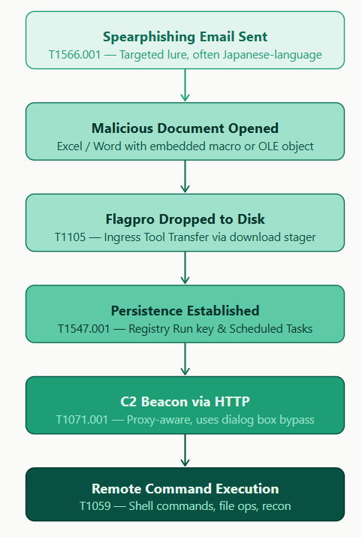

7. Persistence Techniques
Mechanism | Technique | Detail
Registry Run Keys | T1547.001 | Deploys Run Key or Startup Folder entry for boot persistence
8. Privilege Escalation
No specific privilege escalation techniques documented for Flagpro.
9. Defense Evasion
Method | Technique | Detail
Masquerading | T1036 | Deploys names mimicking legitimate Windows utilities
HTTP Blending | T1071.001 | Deploys HTTP C2 blending with normal web traffic
10. Credential Access
No credential access techniques documented for Flagpro specifically.
11. Discovery Techniques
What It Discovers | Technique | Method
System Information | T1082 | Deploys basic system info collection sent to C2 operator
12. Lateral Movement
Flagpro deploys no direct lateral movement. As a first-stage downloader it enables lateral movement by delivering additional tools with lateral movement capabilities.
13. Command & Control
Method | Technique | Detail
HTTP | T1071.001 | Deploys HTTP-based C2 — receives commands and downloads payloads
14. Exfiltration
Flagpro deploys no primary exfiltration. Exfiltration occurs via second-stage payloads deployed by Flagpro.
15. Impact Analysis
Impact Type | Detail
Initial Access | Provides BlackTech initial foothold on Windows systems
Espionage Platform | Enables follow-on espionage operations via second-stage tools
Japan Focus | Targeting of Japanese defence and media sectors
Supply Chain Risk | BlackTech known for targeting subsidiaries to pivot to parent companies
16. IOCs
Type | IOC | Detail
Registry | Run Key entries | Deployed by newly installed non-legitimate processes
Network | HTTP beaconing | From non-browser Windows executables
File | Process names | Mimicking Windows system utilities in unusual directories
17. Detection & Mitigation
Method | Detail
Registry Monitoring | Monitor Run Key and Startup Folder modifications
HTTP Monitoring | Alert on HTTP connections from non-browser processes
Process Auditing | Deploy process execution auditing on Windows endpoints
Threat Intelligence | Blacklist known Flagpro C2 domains via threat intel feeds
18. References
# | Source | Year | Link
1 | NTT Security Holdings — Flagpro Analysis | 2021 | https://www.ntt.com/
2 | CISA — BlackTech Advisory | 2023 | https://www.cisa.gov/
3 | MITRE ATT&CK S0696 | 2022 | https://attack.mitre.org/software/S0696/
]

S0697 — HermeticWiper
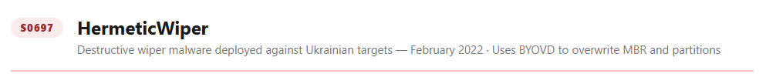
1. Name & Type
Field | Detail
Name | HermeticWiper
ATT&CK ID | S0697
Type | Malware — Destructive Data Wiper
Platform | Windows
First Identified | February 23, 2022
Identified By | ESET Research, Symantec
2. Description
HermeticWiper is a destructive Windows wiper deployed against Ukrainian government, financial, defence, aviation, and IT sectors on February 23, 2022 — the day before Russia's full-scale invasion of Ukraine. It destroys partition information and overwrites the MBR using a legitimate EaseUS Partition Master driver, rendering systems completely unbootable. Its binary was signed with a certificate dated December 2021, indicating months of pre-planned preparation.
3. Threat Actor Association
Field | Detail
Threat Actor | Russia-aligned threat actors
Assessment | Consistent with GRU-affiliated groups
Companion Tools | HermeticWizard (S0698), HermeticRansom
Motivation | Destructive cyber warfare against Ukraine
4. Supported Platforms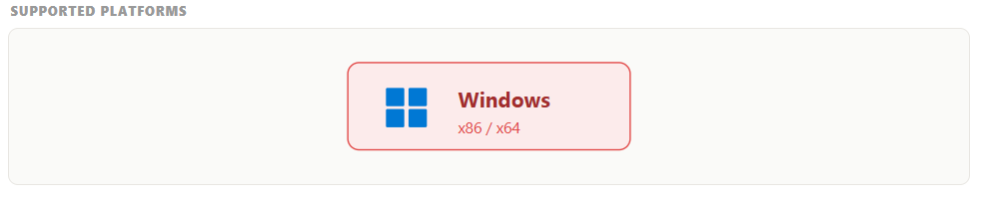
5. ATT&CK Techniques Used
Tactic | ID | Technique Name
Impact | T1485 | Data Destruction
Impact | T1561.002 | Disk Wipe: Disk Structure Wipe
Privilege Escalation | T1134 | Access Token Manipulation
Defense Evasion | T1014 | Rootkit — BYOVD
Execution | T1106 | Native API
Discovery | T1082 | System Information Discovery
6. Execution Method
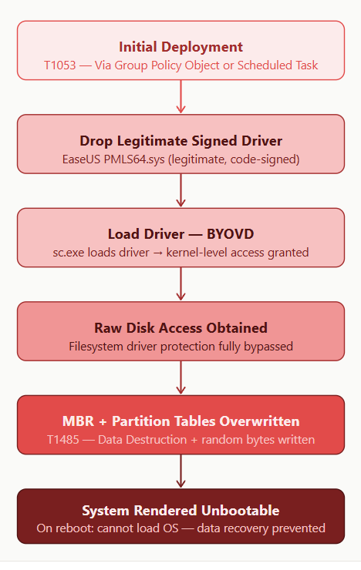
7. Persistence Techniques
HermeticWiper deploys no persistence mechanisms. It is a one-shot destructive payload.
8. Privilege Escalation
Method | Technique | Detail
Token Manipulation | T1134 | Deploys AdjustTokenPrivileges for SeDebugPrivilege, SeBackupPrivilege, SeLoadDriverPrivilege, SeShutdownPrivilege
9. Defense Evasion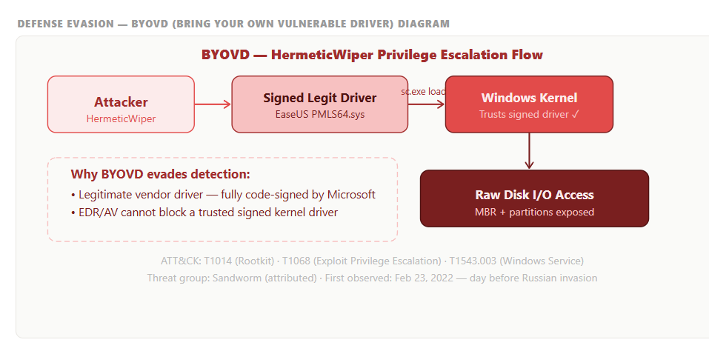
10. Credential Access
HermeticWiper deploys no credential access capabilities.
11. Discovery Techniques
What It Discovers | Technique | Method
Partition Information | T1082 | Deploys partition structure discovery to identify storage targets
12. Lateral Movement
HermeticWiper deploys no lateral movement. HermeticWizard (S0698) was deployed alongside it specifically to spread it across networks.
13. Command & Control
HermeticWiper deploys no C2 functionality. It is a standalone destructive payload.
14. Exfiltration
HermeticWiper deploys no exfiltration capability.
15. Impact Analysis
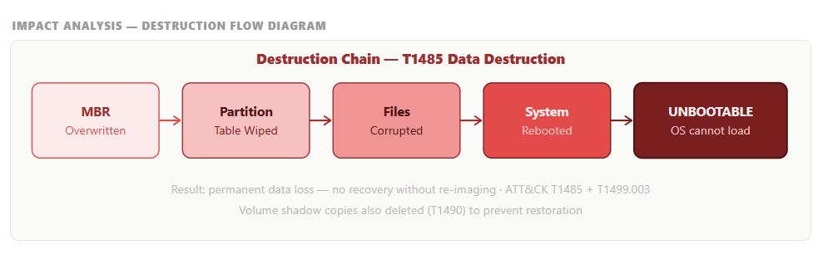
16. IOCs
Type | IOC | Detail
File | empntdrv.sys | Legitimate EaseUS driver deployed for raw disk access
Certificate | Hermetica Digital Ltd | Code signing certificate dated April 2021
Behavioral | AdjustTokenPrivileges | Multiple privilege token deployments in rapid succession
Behavioral | Raw disk writes | Sector 0 writes from non-OS processes
17. Detection & Mitigation
Method | Detail
Driver Installation Monitoring | Alert on driver installation via AdjustTokenPrivileges
Raw Disk Write Detection | Alert on sector 0 writes from non-OS processes
Vulnerable Driver Blocklist | Deploy Microsoft HVCI vulnerable driver blocklist
Offline Backups | Maintain immutable offline backups for recovery
18. References
# | Source | Year | Link
1 | ESET Research — HermeticWiper | 2022 | https://www.welivesecurity.com/
2 | Symantec Threat Intelligence | 2022 | https://www.broadcom.com/
3 | CrowdStrike — HermeticWiper Analysis | 2022 | https://www.crowdstrike.com/
4 | MITRE ATT&CK S0697 | 2022 | https://attack.mitre.org/software/S0697/
S0698 — HermeticWizard
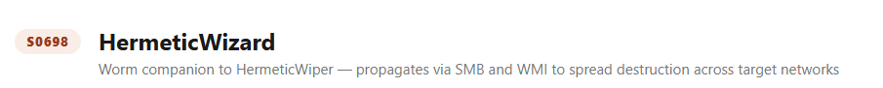
1. Name & Type
Field | Detail
Name | HermeticWizard
ATT&CK ID | S0698
Type | Malware — Worm / Lateral Propagation Tool
Platform | Windows
First Identified | February 2022
Identified By | ESET Research

2. Description
HermeticWizard is a worm designed specifically to spread HermeticWiper across local networks using WMI and SMB. It contains hardcoded credentials to authenticate to remote SMB shares, copies HermeticWiper to remote systems, and executes it via WMI. It represents a sophisticated pairing of a lateral movement worm with a destructive wiper payload.
3. Threat Actor Association
Field | Detail
Threat Actor | Russia-aligned threat actors
Companion Tool | HermeticWiper (S0697)
Motivation | Destructive cyber warfare against Ukraine
4. Supported Platforms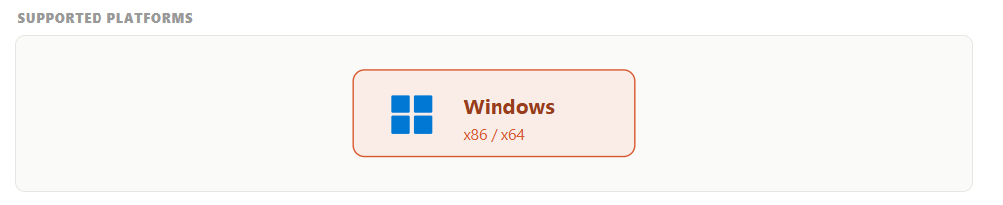
5. ATT&CK Techniques Used
Tactic | ID | Technique Name
Lateral Movement | T1021.002 | SMB/Windows Admin Shares
Lateral Movement | T1047 | Windows Management Instrumentation
Credential Access | T1110.001 | Brute Force: Password Guessing
Execution | T1105 | Ingress Tool Transfer
Discovery | T1018 | Remote System Discovery

6. Execution Method
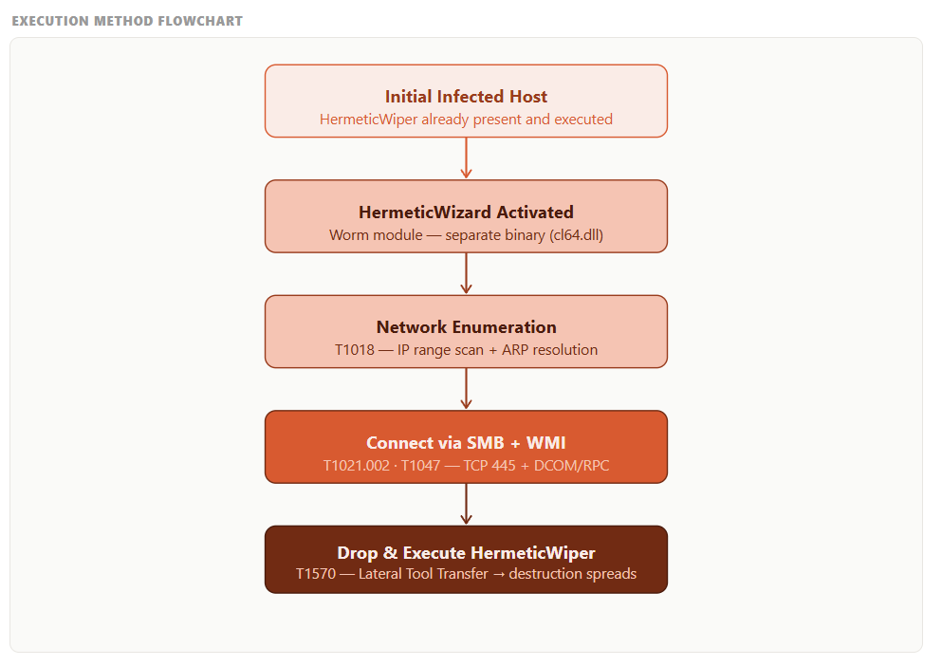

7. Persistence Techniques
HermeticWizard deploys no persistence mechanisms of its own.

8. Privilege Escalation
HermeticWizard deploys hardcoded credentials (T1110.001) for SMB authentication, effectively using credential-based access rather than exploit-based privilege escalation.
9. Defense Evasion

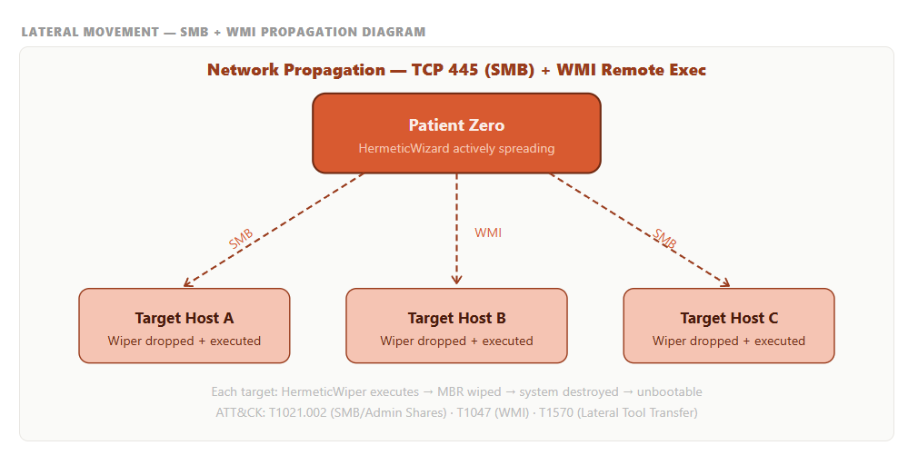
10. Credential Access
Method | Technique | Detail
Hardcoded Credentials | T1110.001 | Deploys list of hardcoded credentials against SMB shares
11. Discovery Techniques
What It Discovers | Technique | Method
Network Hosts | T1018 | Deploys local network scan for accessible hosts
12. Lateral Movement
Method | Technique | Detail
SMB | T1021.002 | Deploys SMB authentication to spread to remote hosts
WMI | T1047 | Deploys WMI remote execution of HermeticWiper
13. Command & Control
HermeticWizard deploys no C2 functionality. It is a standalone worm.
14. Exfiltration
HermeticWizard deploys no exfiltration capability.

15. Impact Analysis

16. IOCs
Type | IOC | Detail
Network | SMB authentication attempts | Deployed using hardcoded credentials across network
Network | WMI remote execution | Unusual WMI calls deploying executables on remote hosts
Behavioral | Lateral SMB traffic | Unusual volume of SMB connections from single host

17. Detection & Mitigation
Method | Detail
SMB Monitoring | Alert on unusual SMB authentication attempts across network
WMI Execution Monitoring | Alert on WMI deploying executables on remote hosts
Network Segmentation | Deploy network segmentation to limit worm propagation
Credential Hygiene | Deploy strong unique passwords to defeat hardcoded credential lists
18. References
# | Source | Year | Link
1 | ESET Research — HermeticWizard | 2022 | https://www.welivesecurity.com/
2 | MITRE ATT&CK S0698 | 2022 | https://attack.mitre.org/software/S0698/

S0699 — Mythic
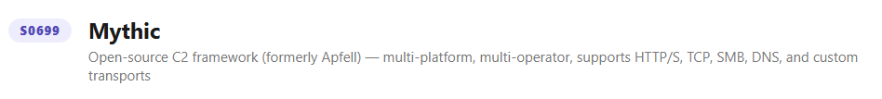
1. Name & Type
Field | Detail
Name | Mythic
ATT&CK ID | S0699
Type | Tool — Open Source C2 Framework
Author | its-a-feature (Cody Thomas)
First Released | 2019
Platform | Windows, Linux, macOS
2. Description
Mythic is an open-source, cross-platform command and control framework designed for red team operations. It features a web-based UI, supports multiple agent types (Apfell, Atlas, Poseidon), and provides extensive post-exploitation capabilities. It has been adopted by multiple threat actors for real-world attacks due to its flexibility, cross-platform support, and active development.

3. Threat Actor Association
Field | Detail
Primary Use | Red team operations — legitimate security testing
Threat Actor Use | Multiple APT groups and ransomware operators
Availability | Publicly available open-source tool
Motivation | Varies by threat actor
4. Supported Platforms
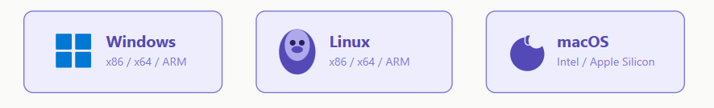
5. ATT&CK Techniques Used
Tactic | ID | Technique Name
C2 | T1071.001 | Application Layer Protocol: Web Protocols
C2 | T1071.004 | Application Layer Protocol: DNS
C2 | T1573 | Encrypted Channel
C2 | T1090 | Proxy
C2 | T1092 | Communication Through Removable Media
Execution | T1059 | Command and Scripting Interpreter
Execution | T1106 | Native API
Defense Evasion | T1620 | Reflective Code Loading
Defense Evasion | T1027 | Obfuscated Files
Lateral Movement | T1021 | Remote Services
Collection | T1005 | Data from Local System
Exfiltration | T1041 | Exfiltration Over C2 Channel

6. Execution Method
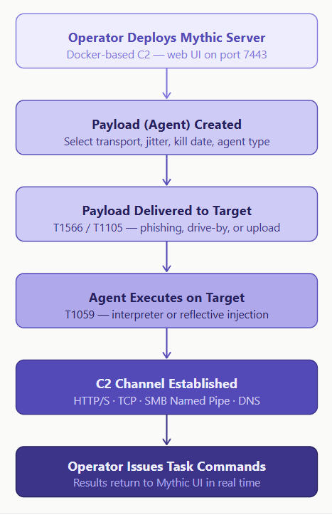

7. Persistence Techniques
Mythic agents deploy persistence mechanisms depending on the agent type and operator configuration.
Mechanism | Technique | Detail
Registry Run Keys | T1547.001 | Deployed by Windows-based Mythic agents
Launch Agent | T1543.001 | Deployed by macOS Mythic agents
Cron Jobs | T1053.003 | Deployed by Linux Mythic agents
8. Privilege Escalation
Mythic deploys privilege escalation modules depending on the agent and operator configuration, including UAC bypass and token impersonation techniques.
9. Defense Evasion
Method | Technique | Detail
Reflective Loading | T1620 | Deploys in-memory agent execution — no disk writes
Encrypted C2 | T1573 | Deploys encrypted communications to evade network detection
Obfuscation | T1027 | Deploys obfuscated agent payloads
Proxy C2 | T1090 | Deploys proxy routing for C2 traffic obfuscation
10. Credential Access
Mythic deploys credential access modules depending on agent type including LSASS dumping, browser credential theft, and keylogging.
11. Discovery Techniques
What It Discovers | Technique | Method
System Information | T1082 | Deploys comprehensive system profiling
Network Configuration | T1016 | Deploys network interface enumeration
Running Processes | T1057 | Deploys process list enumeration
Network Shares | T1135 | Deploys network share discovery
12. Lateral Movement
Method | Technique | Detail
Remote Services | T1021 | Deploys multiple remote service lateral movement methods
Tool Transfer | T1105 | Deploys additional tools to compromised hosts

13. Command & Control
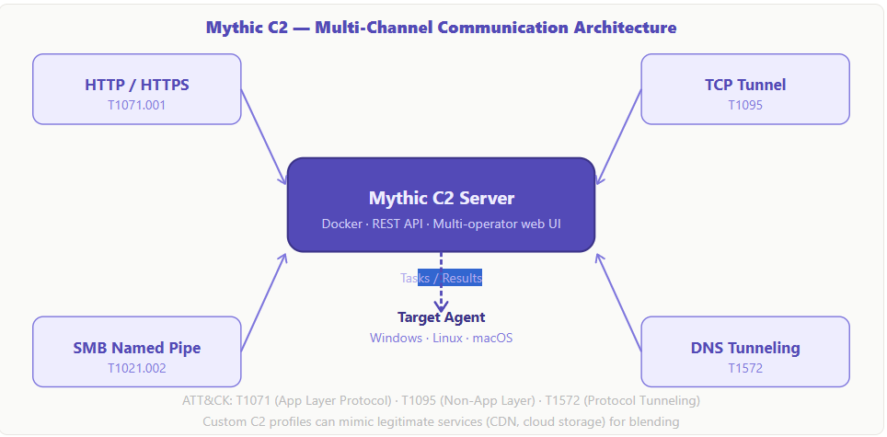
14. Exfiltration
Method | Technique | Detail
C2 Channel | T1041 | Deploys exfiltration over encrypted C2 channel
Local Collection | T1005 | Deploys local file and data collection before exfiltration

15. Impact Analysis
Impact Type | Detail
Full C2 Platform | Provides complete command and control over compromised hosts
Cross-Platform | Deploys against Windows, Linux and macOS simultaneously
Extensible | Plugin architecture enables unlimited capability expansion
Widely Adopted | Used by both red teams and real-world threat actors
Difficult to Attribute | Open-source availability makes attribution extremely difficult
16. IOCs
Type | IOC | Detail
Network | HTTPS beaconing | Regular encrypted C2 beaconing to Mythic team server
Network | DNS C2 | Unusual DNS query patterns from compromised hosts
Behavioral | Agent execution | Unusual process spawning from Mythic agent processes
File | Agent binaries | Obfuscated executables deployed in unusual locations
17. Detection & Mitigation
Method | Detail
Network Monitoring | Alert on unusual HTTPS beaconing patterns
DNS Analysis | Deploy DNS traffic analysis for C2 detection
EDR Deployment | Deploy behavioral EDR to detect agent execution patterns
SSL Inspection | Deploy TLS inspection to detect encrypted C2 channels
Threat Intelligence | Subscribe to Mythic C2 IOC feeds for infrastructure blocking

18. References
# | Source | Year | Link
1 | its-a-feature — Mythic GitHub | 2019 | https://github.com/its-a-feature/Mythic
2 | MITRE ATT&CK S0699 | 2022 | https://attack.mitre.org/software/S0699/

